Logging in to SQL Developer

1 Click on the icon for SQL Developer

2 This screen will appear

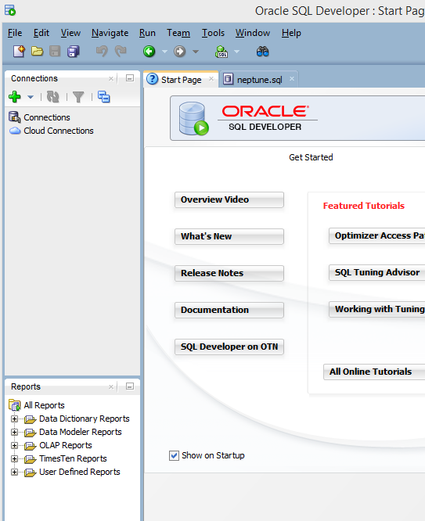

3 Highlight connections in top left and click on the green PLUS sign

4 This screen appears

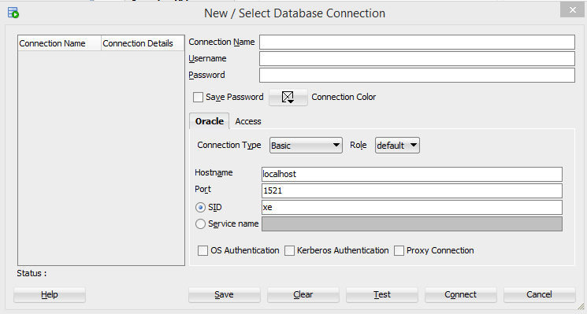

5 Fill in a connection name, your id and password

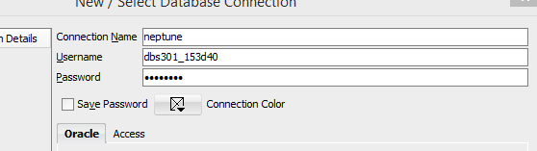

6 Click on drop down menu for connection type and change it to TNS

7 Select network alias as NEPTUNE and hit enter/return.

8 This screen appears

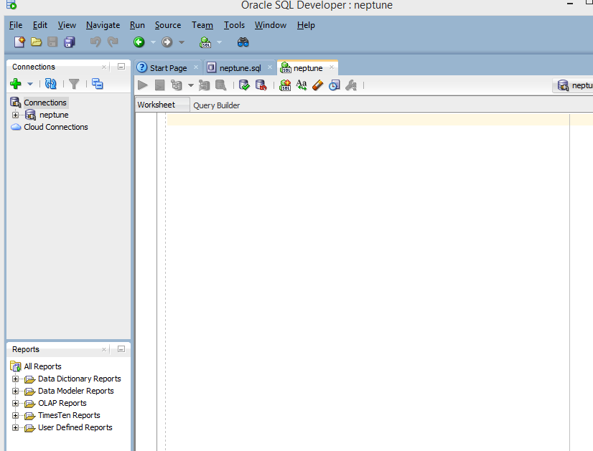

9 To run the script found in the file demobld10 or demoble11, simply open it and enter CTL-A to highlight it. Copy and paste it to the large window above where it states Worksheet and Query Builder.

10 The run icon just above your script will be green. Run the script.

11 Enter select \* from employees; or any other table.

12 The results will appear in bottom half of screen